1.4 Warm-up

The Pythagorean Theorem of Baseball is a formula for approximating a team’s ratio of wins to games played. Let R be the number of runs the team scores during the season, A be the number of runs allowed to opponents, W be the number of wins, and T be the total number of games played. Then the formula
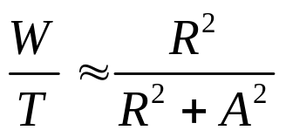
approximates the team’s ratio of wins to games played.
(source: Inside Sports)

a) Solve the formula for W.

b) The 1998 New York Yankees scored 965 runs and allowed 656. How many of its 162 games would you estimate the team won?

